(Approx. 1910 words)

Making the Case for a Better Case
President’s Corner
Greg Skalka, President, Under the Computer Hood User Group
www.uchug.org
president ** unchug.org

If we have nice things, we should want to protect them. We all have a lot of things in our lives that we value and don't want to lose. Some are material things – homes, cars, furniture, investments, and personal items. Some of these are highly valued because they would be costly to replace, and some have great value only to us. Other things we value may not be material but are also treasured – health, happiness, relationships, and capabilities. Some of these valued items are essential and integral to our lives; others are just nice to have, enhancing our lives. Unfortunately, the more we have, the more we have to lose and the more things we need to take care of. The things we need and love can degrade or break, be lost, stolen, damaged, or destroyed. We can lose things through neglect, accidents, hostile acts by others, or our lack of good judgment.

We all want to protect the nice things we have, but with so many possible risks and threats, it can be difficult, especially when we have so many things to protect. Sometimes it is not reasonably possible to protect again stall threats to all our stuff. Depending on the value of something to us and the relative threats against it, we may want to consider insurance against its loss.

Insurance for our prized items can take two forms. One type is a protection against loss, while the other is a compensation for loss. Our automobiles are often critical in our lives, providing essential transportation to a job, school, or store. They can also be a means of recreation and entertainment and a source of personal pride. Many bad things could happen to our vehicles, including theft, vandalism, damage in an accident, and mechanical failure. To ensure these things don't happen, there are actions we can take and things we can buy to help prevent such losses. Parking in a private garage can help prevent thefts and damage that might occur when parked on the street. I have a friend that always parks his truck at the far end of a parking lot, away from other vehicles, to reduce the incidence of scratches and dings from other drivers. Investing in a car alarm system or a steering wheel locking device is often a good way to reduce the chances of theft. Regular vehicle maintenance is good insurance against breakdowns.

Unfortunately, it is difficult to eliminate all risks to your car while still using it. Since a car represents a significant asset for most people, most drivers purchase insurance against loss or damage. A reckless action or unintentional mistake while operating a vehicle could cause great injury or death to another, so our state requires drivers to purchase liability insurance to pay for damages to others and to prevent the personal financial ruin of those at fault. In addition, insurance against the loss of our cars from accidents, fire, theft, and other damage may be warranted if the loss would be a significant cost to us. For an older, low-value car, carrying more than a liability policy may not make sense, but more coverage is prudent for a newer, more expensive vehicle. Even so, depending on the amount of damage and the car's current value, this kind of insurance may not repair your vehicle but only reimburse you for its current value.

Much of our technology is costly and important to our lives and often justifies some insurance against loss. I am often asked by a store, either online or physical, if I would like to purchase product replacement insurance for that TV or other electronic device I am buying. Sometimes this additional coverage may be useful, but it carries a cost. You may also have similar coverage from using a credit card for the purchase or from a homeowners or renters policy. Many personal electronic devices, such as computers and smartphones, are costly to repurchase and so important in our lives that their loss goes beyond money. Imagine losing your phone at a critical time, like when on a trip; the loss can go considerably beyond the cost of a replacement device. Insurance you can buy could replace your device, but it wouldn't typically compensate for the loss of use or data

The most prudent way to handle insurance is to buy only for what you can't afford to lose. For most of us, that extends to a home, car, some household items, jewelry, and firearms. Typically, insuring lower-cost items does not make sense. The only time I bought any replacement insurance for a smartphone was for my daughter's pricey iPhone when she was young, and I knew I'd be responsible for replacing it. To protect my own things, I prefer to ensure my continued use of them by being careful with them.

Smartphones are a valuable item, typically fairly expensive and risky to own. They go out in the world with us as our nearly constant companions and are subject to many dangers our home-bound electronic devices don't face. Our phones are susceptible to being dropped and damaged, submerged in water, stolen, left behind, and lost. Many people have asked me how to dry out a phone; most were unsuccessful in recovering theirs. I've seen many people with cracked phone screens, indicating some accident or mistreatment. It seems rare for a phone to die of "natural causes" (a hardware failure); most seem to suffer an accident or other incident.
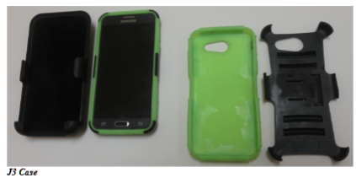
I bought my first smartphone in 2017, and though it was relatively inexpensive (a Samsung Galaxy J3 Prime at $150), I was still concerned that something would happen to it. I didn't take it away from home until I bought a case to protect it. As it turned out, I found the almost perfect case for it. It was just a no-brand case I bought from Amazon (about $25), but it had all the characteristics I was looking for. It starts with a flexible silicon sheath that covers all sides but the screen and has a sizable lip above the screen surface to protect it. There is an opening for the camera lens, connector, and jacks in this cover; best of all, it is a bright fluorescent green color. It was one of the few cases I found of this type that was not just plain black. I sought out this bright coloring not for fashion but for utility. This bright coloring has saved me from accidentally leaving my phone in a dark restaurant booth or anywhere else I might not notice.

This near-perfect case had a hard black plastic piece that snaps on the back, providing a pop-out stand for the phone and additional corner protection. I've accidentally dropped the phone many times, and it has always survived. However, the screen was still vulnerable, so I sought a case with a holster. I have never figured out how people can carry their phones in their pants pockets. The phone seems too big to carry in a front pocket comfortably, and I'm likely to sit on it and break it in a back pocket. The holster can clip on the belt (or the front side pocket opening, where I prefer it) and carry the phone comfortably, with easy access. The phone (and the "permanent" part of the case) slides up and out of the holster; I soon mastered this quick-draw technique.

This case protected my phone so well that the phone suffered no damage or loss in the five years I actively used it. It survived many drops and falls, and I was fortunately careful when handling it (and myself) near water. The only flaw in the case was that it protected my phone so well that it could not survive as long. The holster was the least durable part. I broke the belt clip off a few times (the first time getting into a car with it clipped to my pants), and a hard plastic tab that holds the phone in broke once. The case survived the best; only once did the black part have a tab break-off. Maybe a much more expensive case could have survived the five years of phone use, but I found that buying about five of them worked as well. I just made sure I always had one or two on hand.

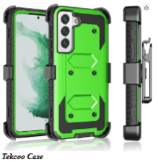
Last June, I decided my five-year-old phone was no longer sufficient, so I bought a Samsung Galaxy S22. I wanted a case exactly like the one I had for my J3, but I could not find one. There were some possible candidates, but none combined the heavy-duty protection, holster with slide-up phone removal, and a bright color element. Desperately needing something to protect my new and expensive ($700) smartphone, I ordered the two most likely candidates from Amazon, one made by Tekcoo and one from Encased.

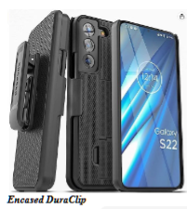
I first tried the Tekcoo case as it had bright green parts, but it seemed cheap (only $10). None of its pieces were very flexible, so I was worried about damaging my phone by snapping it on. The things that really killed me were the integral screen protector that obscured the screen a bit and the holster, which had the phone removed on the long edge rather than the short edge.

The Encased DuraClip case was one of several I considered from this company. At $18, it seemed much higher in quality and had the kind of holster I wanted, but it was all black and offered much less protection than I wanted. The case was relatively thin, rigid plastic, and fit fine, but it offered minimal protection for the top of the phone and none on the bottom. It was almost flush with the screen surface and offered little protection. I immediately needed something to use, so I kept the Encased case and returned the Tekcoo to Amazon.

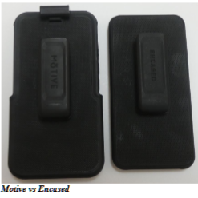
I was still not thrilled about the protection the Encased DuraClip case offered. I considered another from the same company but after a couple of weeks decided to try another brand on Amazon, MOTIVE. Their Bunker series case was much more robust and only $20. The part that made me pause was that the phone was held in the holster by a spring clip rather than sliding in from the top, but I soon got used to that. The MOTIVE case gives much more protection on all sides, with reinforced corners and a thick lip around the screen and the camera. It advertises that it allows the use of a screen protector, so I also bought one that a friend with an S22 recommended, but I have yet to install it. I found this case was far better for protection than the Encase, but since I used the Encased case for several weeks, I didn't feel right about returning it and kept it as a spare.

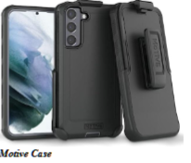
I really like the MOTIVE case, though it is all black and easier to accidentally misplace. I have considered marking it somehow, perhaps with bright paint, but have not yet been motivated. I've dropped it a few times, and the phone has survive d just fine. After using the MOTIVE case for several months, I decided to play the game I played with my J3 phone and bought another as a spare. Just in case (pun intended).

